1. Lumbricus is classified into which phylum?
*a. Annelida
b. Arthropoda
c. Chordata
d. Cnidaria
e. Platyhelminthes

2. Lumbricus have which type of symmetry?
*a. bilateral
b. radial

3. Lumbricus have
*a. a complete digestive system
b. a gastrovascular cavity

4. Which animal is not a member of the same phylum as earthworms?
a. freshwater oligochaetes
b. polychaetes
c. leeches
*d. marine slugs

5. What type of nervous system is found in Lumbricus?
a. anterior pair of ganglia with ventral nerve cords
*b. cerebral ganglia, ventral nerve cords, and segmental ganglia
c. complex folded brain, spinal cord and nerves
d. nerve net

6. Is Lumbricus diploblastic or triploblastic?
a. diploblastic
*b. triploblastic

7. Which type of excretory system is present in Lumbricus?
a. kidneys
*b. metanephridia
c. protonephridia
d. antennal glands
e. no excretory system is present

8. These small, bristle-like structures are made of chitin.
a. annuli
b. clitellum
c. prostomium
*d. setae
e. typhlosole

9. This structure secretes a mucous cocoon into which eggs and sperm are placed by reproducing earthworms.
a. annuli
*b. clitellum
c. prostomium
d. setae
e. typhlosole

10. On the earthworm picture below, the structure labeled “a” is the
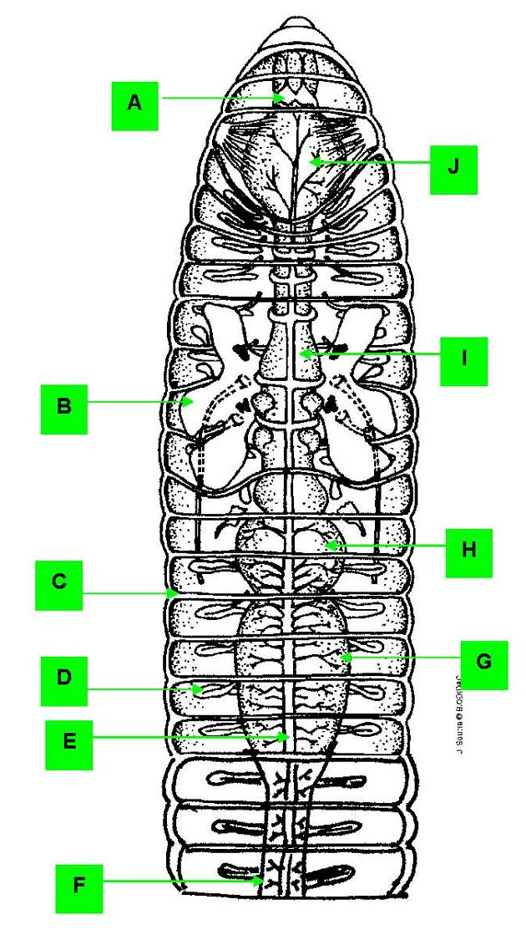

*a. cerebral ganglion
b. dorsal blood vessel
c. metanephridium
d. seminal vesicle
e. septum

11. On the earthworm picture below, the structure labeled “b” is the

a. cerebral ganglion
b. dorsal blood vessel
c. metanephridium
*d. seminal vesicle
e. septum

12. On the earthworm picture below, the structure labeled “c” is the
a. cerebral ganglion
b. dorsal blood vessel
c. metanephridium
d. seminal vesicle
*e. septum

13. On the earthworm picture below, the structure labeled “d” is the

a. cerebral ganglion
b. dorsal blood vessel
*c. metanephridium
d. seminal vesicle
e. septum

14. On the earthworm picture below, the structure labeled “e” is the

a. cerebral ganglion
*b. dorsal blood vessel
c. metanephridium
d. seminal vesicle
e. septum

15. On the earthworm picture below, the structure labeled “f” is the

a. crop
b. esophagus
c. gizzard
*d. intestine
e. pharynx

16. On the earthworm picture below, the structure labeled “g” is the

a. crop
b. esophagus
*c. gizzard
d. intestine
e. pharynx

17. On the earthworm picture below, the structure labeled “h” is the

*a. crop
b. esophagus
c. gizzard
d. intestine
e. pharynx

18. On the earthworm diagram below, the structure labeled “i” is the

a. crop
*b. esophagus
c. gizzard
d. intestine
e. pharynx

19. On the earthworm diagram below, the structure labeled “j” is the

a. crop
b. esophagus
c. gizzard
d. intestine
*e. pharynx

20. On the earthworm diagram below, the structure labeled “a” is the
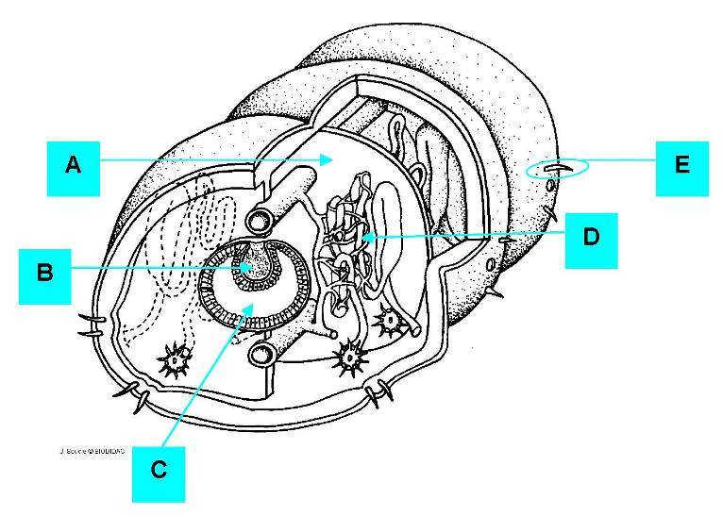

a. lumen of gut
b. metanephridium
*c. septum
d. seta
e. typhlosole

21. On the earthworm diagram below, the structure labeled “b” is the

a. lumen of gut
b. metanephridium
c. septum
d. seta
*e. typhlosole

22. On the earthworm diagram below, the structure labeled “c” is the

*a. lumen of gut
b. metanephridium
c. septum
d. seta
e. typhlosole

23. On the earthworm diagram below, the structure labeled “d” is the

a. lumen of gut
*b. metanephridium
c. septum
d. seta
e. typhlosole

24. On the earthworm diagram below, the structure labeled “e” is the

a. lumen of gut
b. metanephridium
c. septum
*d. seta
e. typhlosole

25. On the photograph below, the structure labeled “a” is the
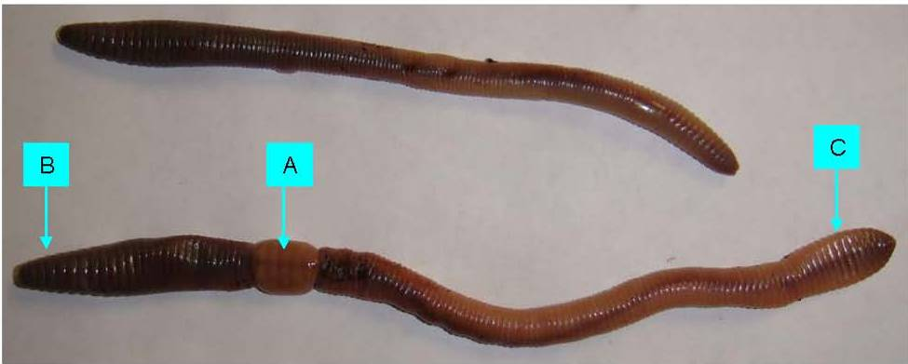

a. anterior end
b. posterior end
*c. clitellum

26. On the photograph below, the structure labeled “b” is the

*a. anterior end
b. posterior end
c. clitellum

27. On the photograph below, the structure labeled “c” is the

a. anterior end
*b. posterior end
c. clitellum

